Setup Apache on CentOS 7

Lab Server Setup:
Hostname 1: www.tto.com
IP Address: 192.168.8.11
Hostname 2: www.student.com
IP Address: 192.168.8.11
Required Packages: httpd
Default config file: /etc/httpd/conf.d
Default Parent Directory : /var/www/html
Default log files: /var/log/httpd/{access_log,error_log}
We will first configure 2 websites (www.tto.com & www.student.com) using the name-based hosting.

Step 1: Update Software Versions List

1. Ensure you are using the latest versions of the software. In a terminal window, input the command:
The system should reach out to the software repositories and refresh the list to the latest versions.
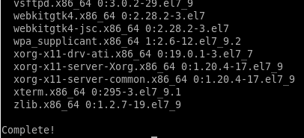

Step 2: Install Apache

1. To install Apache on your CentOS server, use the following command:
The system should download and install the Apache software packages.
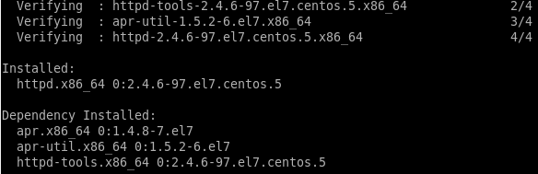

Step 3: Activate Apache

To activate Apache, start its service first.
1. Enter the following command in a terminal window:
This will start the Apache service.

2. Next, set the Apache service to start when the system boots:
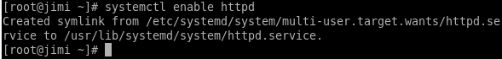

Step 4: Verify Apache Service
1. Display information about Apache, and verify it’s currently running with:
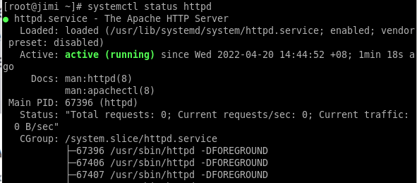

Step 5: Configure firewalld to Allow Apache Traffic
In a standard installation, CentOS 7 is set to prevent traffic to Apache.
Normal web traffic uses the http protocol on Port 80, while encrypted web traffic uses the https protocol, on Port 443.
1. Modify your firewall to allow connections on these ports using the following commands:
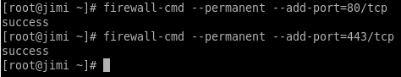

2. Once these complete successfully, reload the firewall to apply the changes with the command:
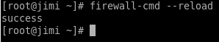

Step 6: Test Apache HTTP Server

1. Setup IP address as below:
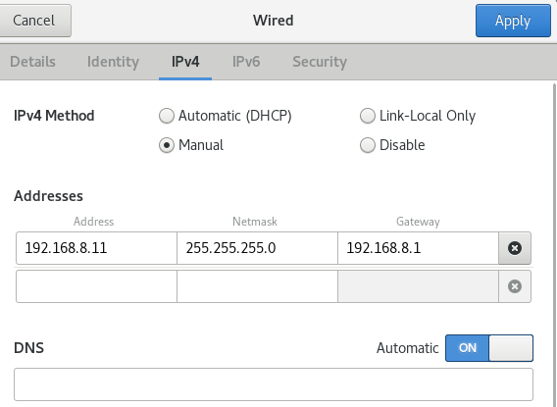

2. Enter your server’s IP address into your browser’s address bar. You will see the default CentOS 7 Apache web page. This is to check whether Apache is already running properly.
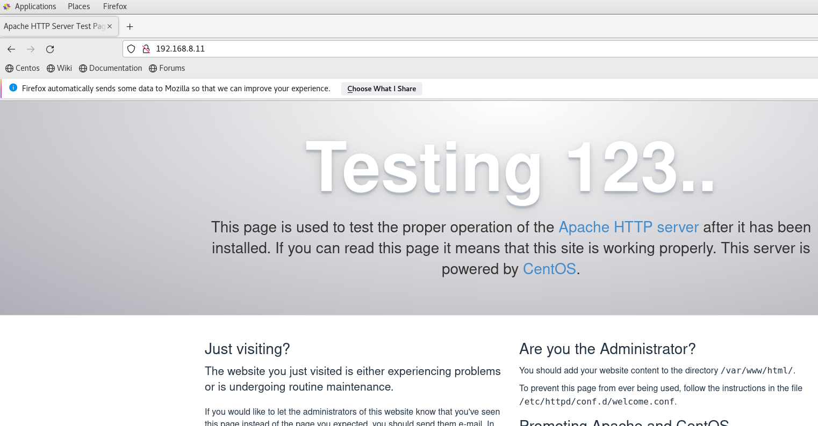

The default configuration for Apache will allow your server to host a single website. To hosting multiple domains on your server, you will need to configure virtual hosts on your Apache web server. The instructions are as below:

Step 7: Setup folder structure for your websites

DocumentRoot is the directory where the website files for a domain name are stored and served in response to requests. The following structure will be used:

/var/www/
├── tto.com
│ └── index.html
├── student.com
│ └── index.html
Example:
tto.com
/var/www/tto.com
student.com
/var/www/student.com

1. We’re creating a separate directory for each domain we want to host on our server inside the /var/www directory.

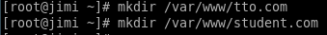

2. Within each of these directories, we will create a index.html directory that will store the domain website files.

3. Open your editor and create a HTML file with the following contents

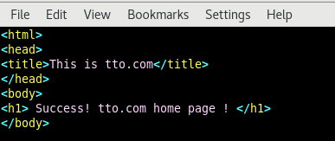

4. Do the same for student.com

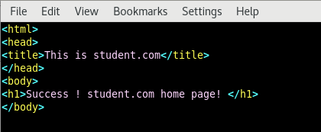

Notes: If you are using sudo, all commands are executed as sudo user, so the newly created files and directories are owned by the root user. To make sure there are no permission issues, change the ownership of the domain document root directory to the apache user:

Step 8: Setting up Virtual Hosts
1. Create the Apache Configuration File
One of the main ways Apache functions is through configuration files. They are located at /etc/httpd.
The Apache configuration file will contain all directives for your virtual host. There are many configurations which you can put into this file, based on your specific needs.
Make sure these configuration files use the .conf extension.

2. For creating Apache configuration file of tto.com:

3. In the editor, enter the following text:
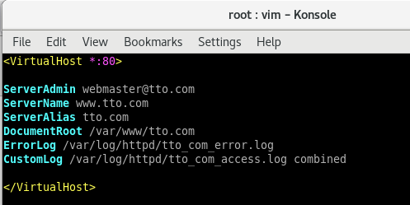
Save and close the editor.

4. For creating Apache configuration file of student.com:

5. In the editor, enter the following text:
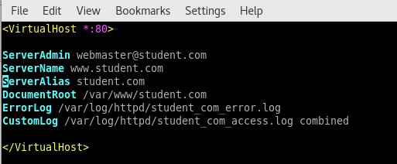
Save and close the editor.

ServerName: The domain that should match for this virtual host configuration. This should be your domain name.
ServerAlias: All other domains that should match for this virtual host as well, such as the www subdomain.
DocumentRoot: The directory from which Apache will serve the domain files.
ErrorLog, CustomLog: Specifies the location for log files.
Edit the file according to your needs and save it.

Step 9: Setting up DNS resolution

1. Since these are dummy websites for testing purposes, we don’t have public DNS entries for www.tto.com and www.student.com. So, we need to do the DNS resolution locally using /etc/hosts file. In our example, our box’s IP address is ‘192.168.8.11, so we add in the following lines:

2. In the editor, enter the following text:
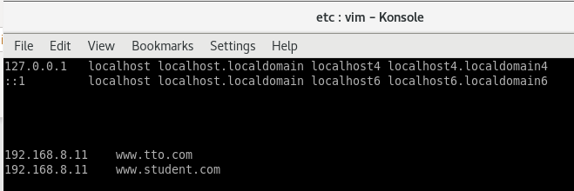
Save and close the editor.

3. Finally, restart Apache service for the above changes to take effect.

Step 10: Testing

1. Open your browser & enter the website url:
www.tto.com
www.student.com

2. You should now see two different webpages with their unique contents.

www.tto.com


www.student.com

